**IFT 466 Advanced Computer Networks**

**Lab 5  
EIGRP – Bandwidth, Delay and Variance**

After you complete each step, put a ‘√’ or ‘x’ in the completed box

**Objective**Gain an understanding of how the relationship between the bandwidth, delay and variance in relation to the metric.

1. Setup up the following topology on Packet Tracer

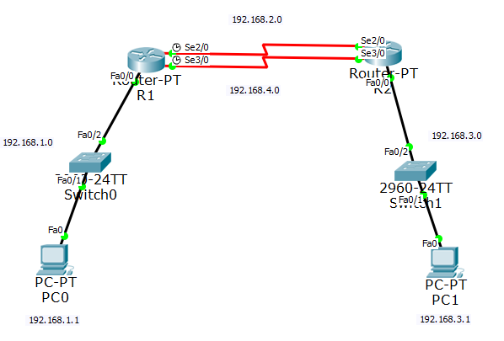

 ✓

1. Configure the PCs and Routers with the following configurations



✓

1. Enable the EIGRP routing process on each router using AS number 1

Advertise directly connected networks via the network command

 ✓

1. Configure the LAN interfaces to not advertise EIGRP updates i.e. passive interface command



✓

1. Verify EIGRP Routing

Use the show ip route to see that the routers have learned the other subnets



✓

1. Verify end-to-end connectivity. PC1, PC2 and PC3 should now be able to ping each other.

If not, troubleshoot your EIGRP configurations.



✓

1. Now re-run the show ip route command on R1. We have 1 EIGRP entry with these two routes as I have two serial connections between the two routers and the route table has a link for both of them.  
     
   EIGRP supports maximum paths settings for the maximum number of equal cost routes, it will put in the route table (default is 4) but have 2 connections so traffic could use both of these links at the same time.

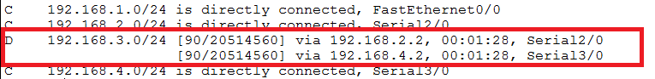



✓

1. Now run the command int serial 2/0 to at the serial interface. EIGRP is measurement is based on bandwidth and delay. For serial interfaces its gets those bandwidth and delay settings from the configuration of the serial interface.

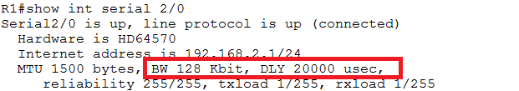



✓

1. Now do a show run command to look at the running configuration and scroll down to the serial interface, the speed of the serial interface is 2000 Kbits per second (2 million bits per second), so my bandwidth setting does not match the actual speed of the interface.   
     
   There is no delay setting on the interface so we are using the default settings for delay.

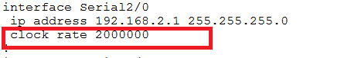



✓

1. We will now change the bandwidth setting of the serial interface so that its accurate on one of the interfaces and see how that affects our routing table.   
     
   As we can, the bandwidth is sets in kilobits, so if we have 2 million for our setting (as above) the we just drop the last three zeros i.e. 2000.

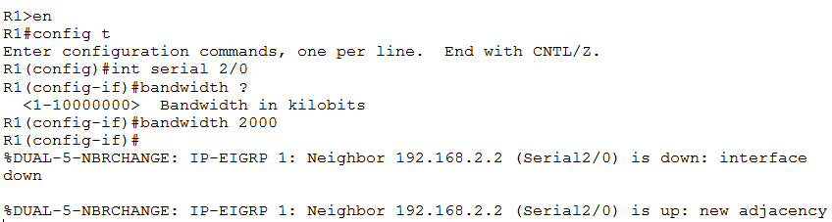

 ✓

1. Make the same bandwidth change on the other router

 ✓

1. Now go back to R1 and look at the serial interface and the bandwidth setting is now correct

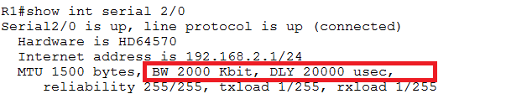



✓

1. Now check the routing table and we can see that the other route dropped out.

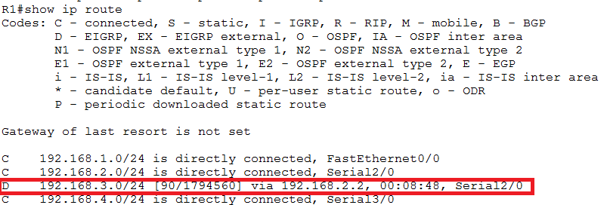

The route that was in there with serial 3/0 is gone. It gone as we did not change the bandwidth on serial 3/0. The serial interface 3/0 is still using the default bandwidth.

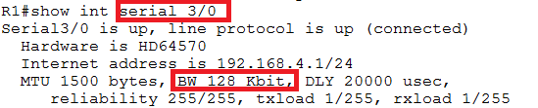

We have taken away half of our capacity for crossing traffic between these two routers links by changing the bandwidth setting on one interface but not changing it on the other. This is based on the way that EIGRP uses bandwidth and delay to calculate its metric.



✓

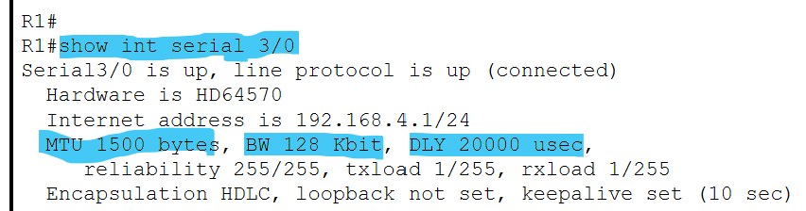

1. Now run the show ip eigrp topology command, we have 2 listings for the network that we are trying to get to 192.168.3.0. One across both serial links with the values (1794560/28160 & 20514560/28160).

This is the metric that is calculated based on way that EIGRP calculates it’s metric and since they are not the same any more, only one of them will be added to the route table.

****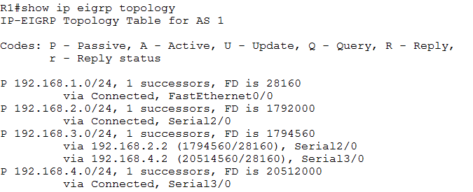

✓

1. We will now change this by updating the bandwidth on the other serial interface (3/0) to bandwidth 2000. Apply the same change to both routers.



✓

1. Check the routing table on R1. Our two routes are back as they both computed the same metric. Since the metric is identical, we can now have them both back in the routing table.

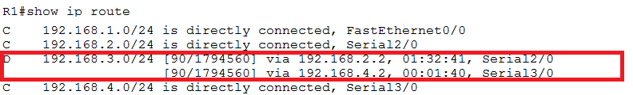

That is why it is important that if you have serial interfaces that you set the bandwidth value accurately. If you don’t set the bandwidth value accurately then you may not be using the best path.   
  
If you set the bandwidth value on some of the interfaces but not on others, you might be losing some of your capacity by not sending traffic over one of the links.

This is how EIGRP uses the metric and how the bandwidth setting effects it.

 ✓

1. Another part of the EIGRP metric calculation is delay. You can change the delay on an interface and that will also change the metric calculation.

We will now change the delay on an interface and see its effects.   
  
Let’s check to see the current day on a serial 2/0 on R1 i.e. 20000 microseconds

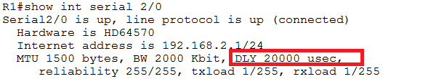



✓

1. We will change the delay to the amount possible (we will make the interface a little bit slower) then will set the value to 2001 on both routers

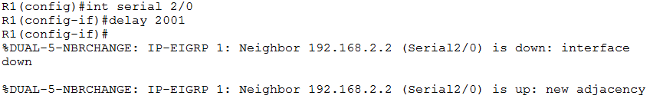

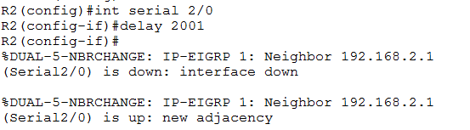



✓

1. Now check out the routing table on R1, we are now back down to one route.

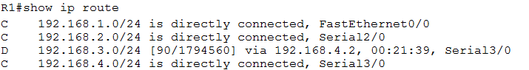



✓

1. We change the route metric calculation by changing the delay by 10 microseconds. 10 microseconds is very small but it causes us to lose a path across the network.   
     
   This is how EIGRP works by default. If the metric it arrives at is identical to another metric of another possible route, it will use that route. If it is different, it will not use it.

  
 ✓

1. Now run the show ip eigrp topology command. The best route has (1794560) while the other route is now 256 higher (1794816), so it is a slower route than the other one.

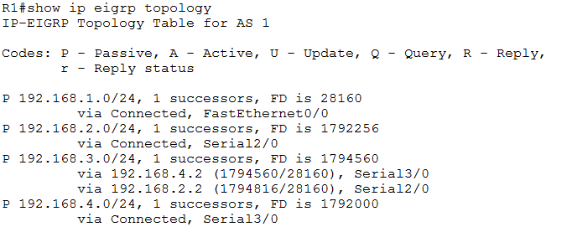



✓

1. That is kind of close (only 256), could we still use that route? We can still use that route, we just need to tell EIGRP to use that other route.  
     
   We will set the variance value to 2.   
     
   If a variance setting of 1, that means that the numbers have to match exactly. If the variance is some other number other than 1, then that controls how far apart they can be and the higher you get with numbers then the further apart they can be (you can set the value up to 128).

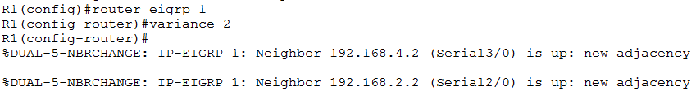

Repeat the same change of variance on the other router



✓

1. Now check out the routing table on R1, both routes are now back in the table. The metrics are not the same but close enough so both get added to the table as we changed the variance.







